

**Web Development 1**

**Module leader: Dr Matt Smith**

**Web site project – semester 1 – 2012**

By submitting your project for assessment you agree to the following:

“The material contained in this assignment is my own original work, except where work is clearly identified and duly acknowledged. No aspect of this assignment has been previously submitted for assessment in any other unit or course.”

# IMPORTANT: Academic Honesty

This assignment is an **individual project**. The work you submit must be your own. It is fine for you to ask a lecturer or fellow student for assistance with the project, but the actual work created and submitted must be your own. Plagiarism and academic dishonesty can lead to failure of the module and other penalties outlined in the Institute’s rules and regulations. For any project or coursework, you should discuss how to best declare the use of work from other sources with your lecturers.

# Important points about this project: List image sources in file: sources.txt

The **design** of your web pages and the **coding** of the individual components must be your own original work. However, you may use and adapt examples from the module materials/moodle without having to declare them.

For this project the **only** content you may use from other sources are images. For each image you must declare where it came from, by providing the URL and original filename. Do this in a separate files named: **sources.txt**

Just as you would have to specify the book and page for a text quotation, you have to specify the website for images (saying Google Images is NOT sufficient!) – you must provide the URL from which the image can be found, and if necessary, the copyright author could be contacted to request commercial use of the image.

NOTE: All text in your website must have been written BY YOU. Do not copy and paste text about TV shows into your HTML pages. There does not have to be a lot of text in your website – a few sentences on each page could be fine.

**The website project task**

You are to create and submit the following:

**(a)** a folder containing set of web pages about a TV Show

**(b)** a text file declaring your image sources (named “sources.txt”)

Every student must create a website on a different TV show, so you need to talk to your lecturer. The lecturer will publish a list of the TV show choices approved for each student – only start work on your website once your project choice has been published by the lecturer.

Your website folder should contain the following:

**index.html** (home page)

**/images** (folder directory for all the images)

**/css** (folder directory for your CSS file(s))

Plus 10 or more HTML pages of the following (choose appropriate (lower case) file names!)

* summary of TV show
* site map (all website pages listed, showing site structure, as links to all pages)
* about the characters in the TV show
  + have a main characters page and then separate pages about each character
  + remember **all text on your website must be your own original prose writing**
* about the episodes (and/or series) of the show
  + again have a main page and then separate pages for each episode/series
  + remember **all text on your website must be your own original prose writing**
* merchandise – details of some show related products that can be purchased (e.g. t-shirts, mugs, DVDs/videos etc.)
  + you can make these up if you wish!
* any other pages you wish to add about the TV show

An example of *possible* web site structure:

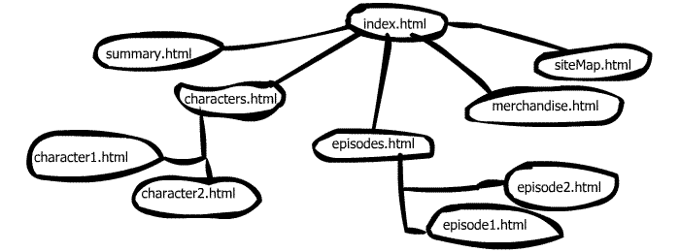

NOTES:

* Your website project is the most important way for you to demonstrate appropriate and consistent application of your learning of the module knowledge and skills
* See the provided **indicative marking grid** for additional details about the grading criteria
* A grade will only be awarded after demonstration/defence in person to the lecturer
* Projects submitted on a topic different to that published by the lecturer for the student will score zero